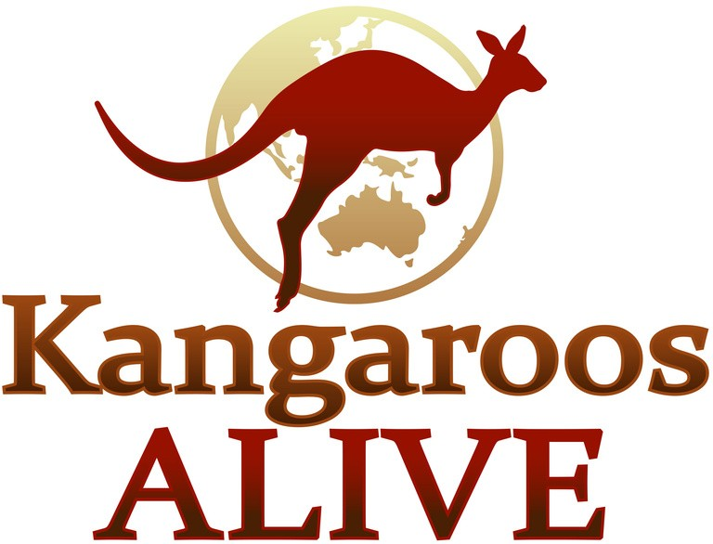

CEO: Simon Hickey
GreenCross DBA PetBarn PTY,LTD Unit 6 372 Eastern Valley Way Chatswood, NSW Australia 2067

Dear Simon,

Kangaroos and wallabies are the only Australian native animal hunted specifically for the pet food trade.

Do you know the brutal reality of the commercial kangaroo industry?

A recent NSW parliamentary inquiry into the he Health and Wellbeing of Kangaroos has released its findings and they are shocking.

The parliamentary inquiry found that there is no monitoring of commercial kangaroo shooters at the point of kill, This lack of any regulation has caused an animal welfare crisis, with data presented to the inquiry showing that up to 40% of kangaroos are mis-shot and left to die painful slow death.

The inquiry also found that neither Federal or state governments keep any records of how many baby joeys are killed. We have no idea how many baby joeys are killed each year. The baby joeys are the forgotten animal in the pet food trade. After the kangaroo mother is shot by commercial shooters, the joey is wrenched from it's pouch and bashed to death or decapitated, while the at-foot dependent joeys are left to die as orphans from starvation, dehydration, stress and predation.

The parliamentary inquiry reported that the commercial shooters are not monitored and are not required to report how many joeys they kill and how they do it!

The killing of kangaroos is the world's largest land-based wildlife slaughter in the world and the inquiry found “kangaroo numbers are in serious decline with mobs becoming marginalised and fragmented throughout the landscape”.

"Kangaroo meat is known to be contaminated on occasion with Salmonella spp, high levels of E. coli, Toxoplasmosis, and Listeria, and Coxiella” Dr Dror Ben-Ami, Centre for Compassionate Conservation, University of Technology, Sydney.

As a result of this shocking new evidence several big brands in Europe have stopped using kangaroo meat and skins, brands like Prada, Versace, and Carrefour supermarkets. A bill is being prepared to put before the European Union to ban all imports of kangaroo meat and skins.

A recent ABC TV 730 story on the NSW Inquiry is available to watch https://www.facebook.com/702550123508373/videos/411660887253188

Kangaroos have inhabited the Australian continent for over 20 million years, living in peace and ecological harmony and they are a sacred totem for our First Nation People.

The truth has been uncovered by this parliamentary inquiry. We now know how cruel and barbaric the commercial killing of kangaroos is.

It is time to stop killing our kangaroos for pet food.

Your company could be the example, not to condone this barbaric behaviour. We call on Petbarn to stop selling pet food made from kangaroos.

Our supporters want to go public with a campaign to stop kangaroos being used for pet food. We look forward to your response by Monday 13 December 2021.
Regards,

Mick McIntyre
Executive Director Kangaroos Alive

